Analysis and Requirement
2.1 Problem Analysis
Modern web and mobile applications frequently undergo UI changes due to dynamic front-end frameworks like React, Angular, Flutter, and Jetpack Compose. These changes break automation scripts that rely on static locators such as XPath, ID, class name, or accessibility ID. Even small DOM shifts cause failures like NoSuchElementException, StaleElementReferenceException, and ElementNotInteractableException.
Because existing automation frameworks lack intelligent adaptability, they suffer from:
- Flaky tests caused by minor UI changes
- Hard-coded, brittle locators that break too easily
- High maintenance effort for long-running test suites
- No automatic repair mechanism for failing elements
- Separate frameworks for Web (Selenium) and Mobile (Appium), increasing redundancy
This results in low automation stability, poor CI/CD reliability, and reduced confidence in automated testing.

2.2 Existing System
The existing automation process depends heavily on manual script updates. When an element changes its structure or attributes, the automation script cannot adapt. The tester must inspect the DOM, find a valid locator, update the script, and rerun the execution manually.
Limitations of the current system:
- No intelligence to detect locator changes
- UI changes cause complete script failure
- No cross-platform unified automation structure
- Logs and failures must be manually investigated
- No centralized reporting or healing analytics
Thus, the current system lacks both flexibility and automation maturity.

2.3 Proposed Solution
The proposed Hybrid Cross-Platform Automation Framework with Self-Healing addresses the limitations by introducing an AI-assisted healing engine that automatically detects and repairs broken locators during runtime.
Key Capabilities
- Self-healing plugin layer to intercept failures
- AI-based locator healing using:
  - XPath heuristics
  - DOM similarity comparison
  - Attribute pattern matching
  - Fallback locator generation
- Unified framework supporting both Selenium (Web) & Appium (Mobile)
- Plug-and-play modular architecture
- Centralized reporting dashboard for screenshots, logs, and analytics
- Jenkins CI/CD integration for continuous automated execution
This improves automation stability, reduces maintenance, and ensures scalability.

2.4 Functional Requirements
FR1 – Ability to execute web automation tests
FR2 – Ability to execute mobile automation tests
FR3 – Automatic locator detection and self-healing
FR4 – Capture logs, screenshots, reports, and errors
FR5 – Support parallel execution and cross-platform runs
FR6 – Dashboard displaying reports, retries, and stability index
FR7 – Jenkins integration for continuous execution in pipelines

2.5 Non-Functional Requirements
Performance:
Self-healing should not significantly slow down test execution.
Reliability:
Healing engine should consistently detect and repair broken locators.
Usability:
Framework should be simple to extend with new test modules.
Scalability:
Must support large-scale test suites and multiple devices/browsers.
Portability:
Must run on Windows, Linux, and Mac environments.
Security:
Logs, screenshots and test data must be properly secured and version-controlled.

2.6 UML / Analysis Models
Use Case Summary:
Actors:
- Automation Engineer
- CI/CD System
Use Cases:
- Run Web Tests
- Run Mobile Tests
- Heal Locator at Runtime
- Generate Reports
- Publish Reports to Dashboard
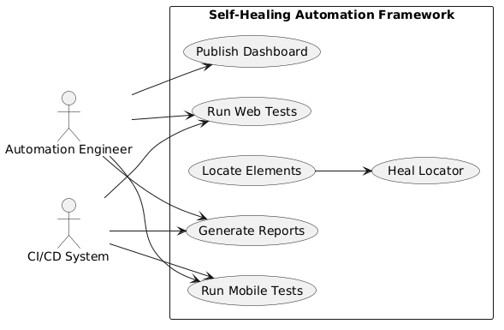

System Flow Explanation
- Test starts
- Locator fails
- Self‑Healing engine intercepts
- Heuristics applied
- New locator generated
- Test continues
- Report generated
